Alcatel U3

Type of device: Mobile
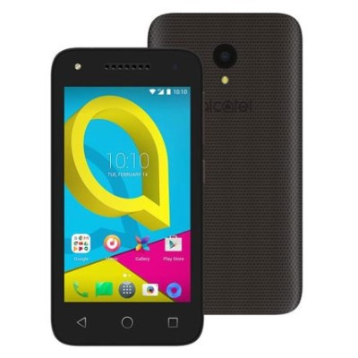

Actual Display Size : 4 inches
Button Type : Touchscreen
Operating System : Android
Version Number : Android 6 (Marshmallow)
Network Capability : 3G
Year of Release : 2017
Average Price : $79 as of 18 05 2021

Accessibility Features:

Cognitive
- Additional Instructions
- Copy and Paste
- GPS
- Photo Telephone List
- Screen Timeout Disabled
- Simple Instructions
- Simple Reminders
- Simplify Display
Voice Notes

Hearing Impairment and Deaf
- Allows for sign language communication
- Bluetooth or Wi-Fi
- Closed Captioning
- Front Facing Camera
- Hearing Aid Telecoil Coupling
- Text Messaging/SMS
- Vibrating Alerts - Adjustable
- Video Communications - Two-way
Visual Alerts - Incoming Calls

Vision
- Battery Alert - Audible
- Bluetooth or Wi-Fi
- Braille Display Support
- Brightness Adjustable
- Dictation / Speech-to-Text
- High Contrast Mode
- Power Cue
- Screen Magnifier
- Screen Reader
- Text Size Adjustable
- Text Style Adjustable
Voiced Menus

Speech
- Allows for sign language communication
- Bluetooth or Wi-Fi
- Messaging Options - Email
- Messaging Options - IM
- Messaging Options - MMS
SMS Personalisation and Reuse

Physical
- Bluetooth or Wi-Fi
- Dictation / Speech-to-Text
- Flat Back for Table Top Operation
- Headset - plug connected
- Predictive Text
- Speaker-phone option
- Stylus or Prosthetic Device support
- Switch control option
- Voice Recognition for Accessing Features
Voice Recognition for Dialling

How and where to get it from?
You can buy this phone from Domayne, Harvey Norman The Good Guys, and other retailers.

More information is available on:
Alcatel U3 Web Page
Alcatel U3 User Manual (PDF Download)

